Thermal History Paint case study
Petrol engine turbocharger components
Sensor Coating Systems (SCS) worked with a German automotive supplier to successfully deliver over 1000 temperature measurements on 4 different turbocharger components using the novel Thermal History Paint technology. The paint remained adherent on all 4 components; the turbine wheel, housing, heat shield and compressor wheel and the measurements covered a wide range, 100-1000°C. The results provided very important information in previously inaccessible locations.
Key facts | Industrial sector | Automotive | Temperature range | 100-1000°C
Key facts | Components | Turbine wheel, turbine housing, heat shield, compressor wheel
Key facts | Component materials | Metal alloys | Test duration | ~10 minutes

Quote from customer | “We were very satisfied with the results and the reporting provided by SCS. We were amazed how well the new paint resisted against erosion. In our experience, it provided much better applicability than traditional colour changing thermal paints giving an immediate advantage when testing the compressor wheel. In our view, Thermal History Paint is a unique measurement technique for detailed thermal mapping, well suited for turbo charger applications. ”

Introduction
The customer was looking for a new temperature measurement tool to acquire data to validate their simulation models of turbocharger designs. Traditional temperature measurement techniques are practically very challenging to apply on turbochargers due to the extremely high rotational speed and complex geometry of the components. Previous attempts with colour changing thermal paints had been unsuccessful due to difficulties in balancing and the limited durability of the paint. They recognised that the Thermal History Paint (THP) technology¹ offered a new and unique solution. Developed and patented by SCS, THP has significant advantages over existing temperature measurement techniques that are key for application on turbochargers, as summarised below:
Major benefits of THP | No access during operation | Non-toxic paint | Objective interpretation
Major benefits of THP | 3D temperature profiles | Durable coating | Automated read-out

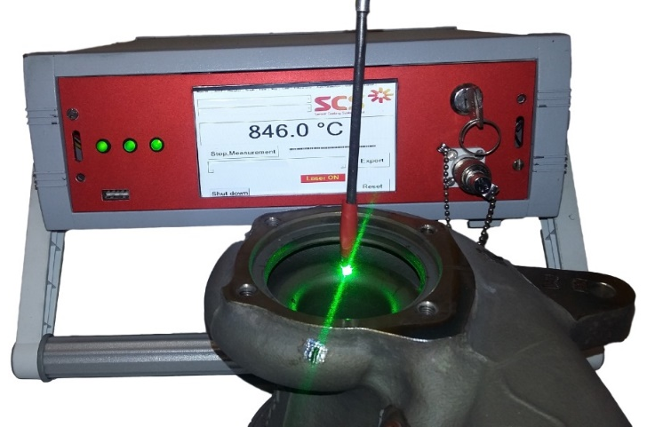
Results on the rotor
Measurement device
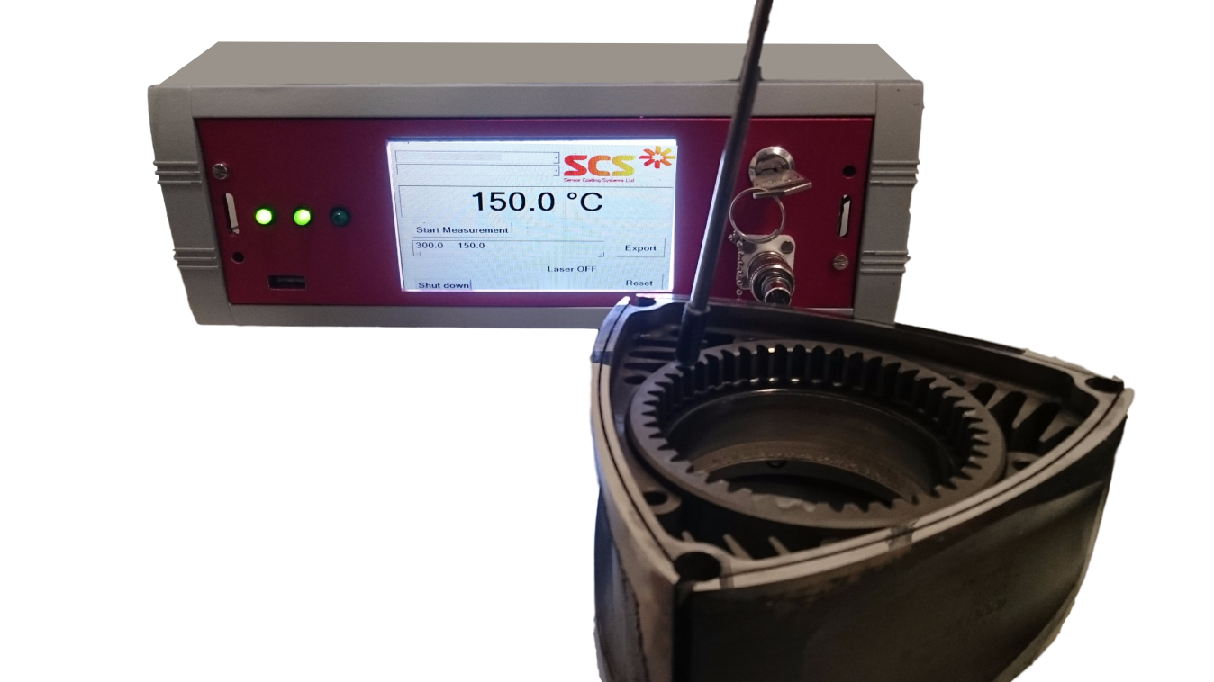
THP was applied to 4 different turbocharger components; the turbine wheel, turbine housing, heat shield and compressor wheel. The painted components were installed and operated by the turbocharger manufacturer in a test rig. After operation, the THP remained on all components, including both wheels, with only minor damage on the heat shield at the gas inlet.
Probe
Turbine housing
Over 1000 data points were measured on the four components covering 100-1000°C. The temperature gradient along the turbine and compressor blades was quantified. The thermal profile of the gas volute indicated higher temperatures at the gas inlet. The results were, in general, in good agreement with expectations. With the THP it was also possible to record temperature data where it had previously not been possible. New observations were made that provide fresh insight into the thermal processes inside the turbocharger and are under further investigation to develop a greater understanding of the components, hence improving future designs.
A measurement in action on the turbine housing.
- Journal publication on THP available at: http://turbomachinery.asmedigitalcollection.asme.org/article.aspx?articleID=2237963

